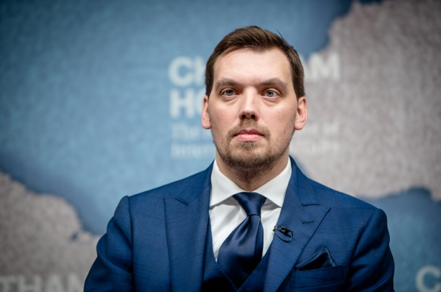 | Oleksiy Honcharuk  Former Prime Minister of Ukraine (2019-2020)  Deputy Head of the Office of the President of Ukraine (2019)

Professional experience:
            - Prime Minister of Ukraine, August 2019 – March 2020
Achievements:
- Launch of large and small privatization processes (the Cabinet has prepared and transferred for privatization almost 1000 unprofitable enterprises, which is 10 times more than had been done in the previous 10 years).
- Preparation of land market legislation with its further adoption by the Parliament.
- Provision for European energy security. In record 4 months, the Cabinet conducted Naftogaz unbundling. This decision allowed to conclude a new gas transit contract between Ukraine, the EU and Russia.
- Launch of affordable loans for Ukrainian micro and small business.
- The holding of first transparent concession competitions for two Ukrainian seaports. Another 10 objects were prepared by the Cabinet for the competitions.
- Launch of “State in a Smartphone” project. Majority of State services went online.
- Started combating shade markets –– illegal gambling houses and petrol stations were closed.
- Launch of Anti-Raider (illegal seizure of business or property) Office that would react within just 24 hours to any cases of such illegal seizure.

            - Deputy Head, Office of the President of Ukraine (economic policy), June 2019 – August 2020
            - Member of the National Council of Reforms of Ukraine (representative of the expert community), 03 July 2016 – May 2019
            - Head of Better Regulation Delivery Office (BRDO). Advisor to the First Vice Prime Minister of Ukraine – Minister of Economic Development and Trade of Ukraine, September 2015 – May 2019.

Responsibilities: creating and introducing a system of effective regulation. Priorities: better rules for business; favorable investment climate; improving Ukraine’s position in Doing Business rankings.

Achievements:
- The Parliament of Ukraine adopted 8 better regulation packages, drafted with BRDO’s expert contribution, that resulted in the cancellation of over 1000 outdated legal acts and the launch of new markets (mobile payments market, etc.);
- The Cabinet of Ministers of Ukraine adopted about 30 decisions developed and advocated by the BRDO;
- Creation of PRO Platform for Effective Regulation at http://regulation.gov.ua – an information resource that enables meaningful online interaction between State and business in Ukraine;
- Creation of Inspection Portal Web Service (IAS) Pilot Module at http://ias.brdo.com.ua containing information on over 110,000 approved inspections and over 30, 000 combined inspections, and with 26 registered inspection bodies that use the system to perform inspection planning and reporting functions.

- Advisor (Acting Deputy) to the Minister of Ecology and Natural Resources of Ukraine, December 2014 – April 2015 (www.menr.gov.ua)

Responsibilities: natural resource management (land, subsoil, forest, water, bio resources). Priorities: reform of subsoil use and management.

Achievements:
- Launch of a new information portal on geology and subsoil of Ukraine at http://geoinf.kiev.ua/wp/interaktyvna-karta-rodovyshch-korysnykh-kopalyn.htm, which opened up extensive information on Ukraine’s natural resources for the first time;
- Launch of Single Window for the Ministry of Ecology and Natural Resources of Ukraine;
- The Cabinet of Ministers of Ukraine adopted amendments to Decrees concerning auctions for the right to extract minerals, which put an end to a significant part of corruption schemes;
- Development of the Concept and Action Plan for the creation of a Center for Natural Resource Management at the Ministry of Ecology and Natural Resources of Ukraine.

- Attorney, Arbitration Manager, Founder and Managing Partner of Constructive Lawyers Law Firm (until 2008 - YUSTIS Law Firm), among the TOP-75 law firms of Ukraine (2011 – 2015). www.c-lawyers.com, October 2008 - December 2014

- Chairman of the Permanent Court of Arbitration at the Nation-wide NGO Union of Investors of Ukraine, one of the most successful arbitration courts in Ukraine. www.arbitrate.com.ua, August 2009 – December 2014

- Deputy General Director of First Ukrainian Industrial-Investment Company LLC, specialist in securities trading, April 2005 - August 2008

Responsibilities: Legal support, GR and PR, security, 28 staff under management.

Community Engagement, Research

- Co-organizer of translation of Nelson Mandela's autobiography "Long walk to freedom" (2014) into Ukrainian.
- Co-founder and member of Syla Lyudey non-governmental organization and political party (http://sylalyudey.org). An active participant in the Revolution of Dignity and Ukraine’s Volunteer Movement.
- Chairman of the Public Committee for the Protection of Electoral Rights of Citizens at the Ukrainian Parliament Commissioner for Human Rights (2012).
- Co-author of the research and practical commentary to the Law of Ukraine "On Elections of Members of Parliament of Ukraine" (edited by Professor Victor Musiyaka) (2012).
- Co-founder and Chairman of All-Ukrainian Union of Investors of Ukraine NGO, www.investhelp.com.ua (2008-2013).

